Power platform limited access to create environment.

*Prepared By:  
 --Vatsal Patel*

* We can restrict that every user of tenant will not ably create the environment in power platform. To restrict that we have to make some changes form power platform settings.

1. Login with admin rights in power platform. (<https://admin.powerplatform.microsoft.com>)
2. Go into settings.

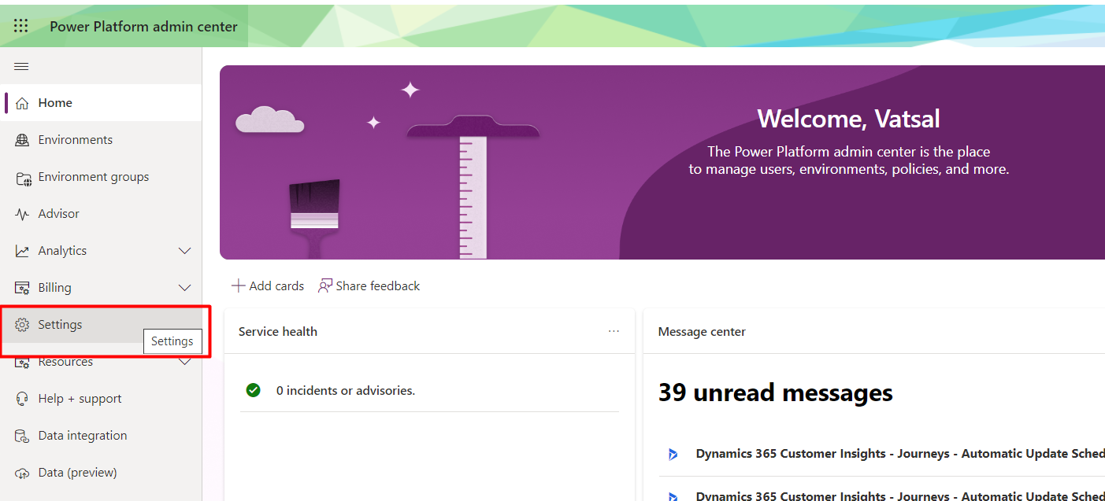

1. In the settings find settings for Developer, production, and trial environment assignments. Make changes as per below screenshot. Once you made changes so every will not able to create power platform environments. Once they get Global administrator, D365 service admin power platform service admins or delegate admin role than an only they will be able to create environments.

